**DAILY ONLINE ACTIVITIES SUMMARY**

|  |  |  |  |  |  |  |  |  |
| --- | --- | --- | --- | --- | --- | --- | --- | --- |
| **Date:** | **26/05/2020** | | | | | **Name:** | **Sheetal** | |
| **Sem & Sec** | **8 B** | | | | | **USN:** | **4AL16CS091** | |
| **Online Test Summary** | | | | | | | | |
| **Subject** | | **BDA** | | | | | | |
| **Max. Marks** | | **40** | | **Score** | | | **30** | |
| **Certification Course Summary(Internship)** | | | | | | | | |
| **Task** | **Study-Learning data analytics concepts with platform specified**  **POC- working on development of custom visual for the dashboard using typescript language** | | | | | | | |
| **company** | | | **Gain-insights** | | **Duration** | | | **9 hr** |
| **Coding Challenges** | | | | | | | | |
| **Problem Statement:**  **1) write a python program to read a number and print the series"1+2.."** | | | | | | | | |
| **Status:completed** | | | | | | | | |
| **Uploaded the report in Github** | | | | | **Yes** | | | |
| **If yes Repository name** | | | | | [alvas-education-foundation](https://github.com/alvas-education-foundation)/ **[sheetal-shettigar](https://github.com/alvas-education-foundation/sheetal-shettigar)** | | | |
| **Uploaded the report in slack** | | | | | **Yes** | | | |

ONLINE TEST:

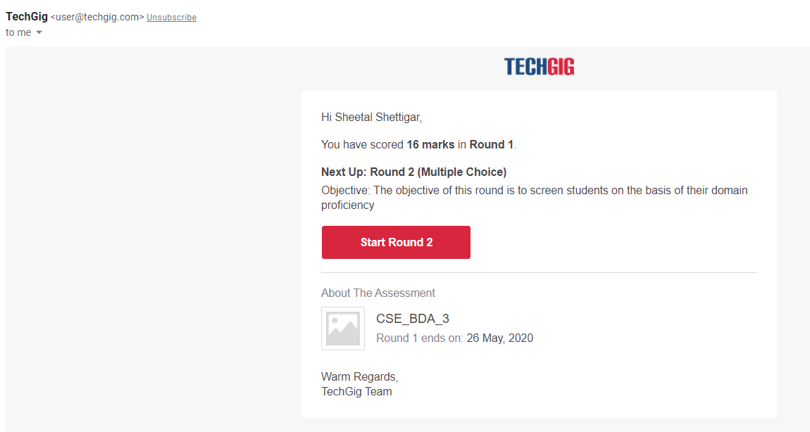

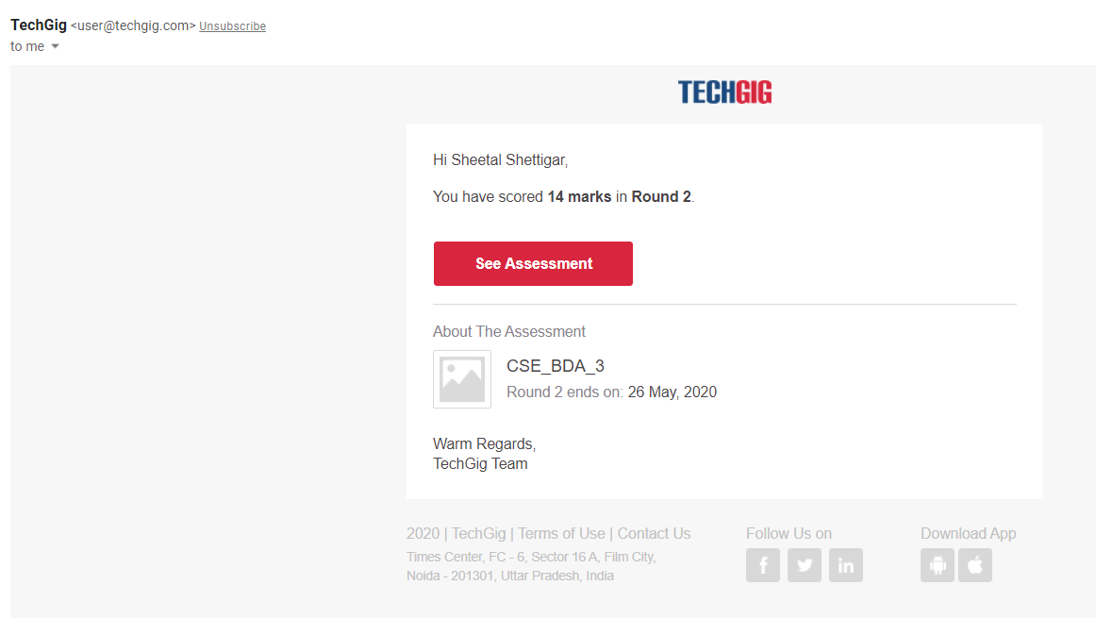

CODING CHALLENGE:

PROGRAM 1 :

n = int(input("Enter a Number : "))

series_sum = []

for i in range(1,n+1):

series_sum.append(i)

if i==n:

print(i, end='')

else:

print(i,end=' + ')

print(' = ', sum(series_sum), sep='')